Dear Parents of pupils at school in and around Winchester,

05June 2024

Mr Edmund Lewis

Head of Classics

Winchester College

**Information about Winchester Greek Club: a free after-school club devoted to the study of Classical Greek for pupils in and around Winchester in year 11**

I am writing to let you know about an after-school club in which young people in the Winchester area with an interest in the ancient world are able to study Classical (i.e. ancient) Greek. No previous knowledge of Greek is expected. In their first year participants work towards the [Intermediate Certificate in Classical Greek](https://intermediategreekcert.com/); those who wish to continue then work towards the [OCR GCSE](https://www.ocr.org.uk/qualifications/gcse/classical-greek-j292-from-2016/) in the second year. For year 11s joining, the GCSE would fall at the end of year 12, and therefore not clash with the rest of their GCSEs or with A-Levels.

The Winchester Greek Club launched in September 2022 and proved very popular in its first year: we had as many as 26 participants coming weekly on Thursday afternoons in the autumn term, and 18 continued until the end of the year and sat the Intermediate Greek Certificate. 14 of those stayed for the second year and sat the GCSE exams in summer 2024; meanwhile a second cohort of almost 20 participants is following behind them.

Young people in Winchester are fortunate in having good opportunities to study Latin, and with it the civilisation of the ancient Romans: the subject is offered up to GCSE at Kings’ School, the Westgate School, St Swithun’s and Winchester College, and at A-Level at these last two and at Peter Symonds College. However, at present Classical Greek is only offered at St Swithun’s and Winchester College. The Winchester College Classics department launched the Winchester Greek Club in order to fill the gap.

The glories of the Greek language and of Greek civilisation, together with the rarity of the opportunity to study them, are strong incentives to participate; in addition, the attractiveness of the qualifications on university applications and the chance to meet young people with similar interests from other schools should not be overlooked. The classes are good fun, and we spend plenty of time exploring Greek civilisation even if our main focus is the language. Club members have attended Classics talks at Winchester College and taken part in a trip to Oxford to visit the Ashmolean Museum’s *Labyrinth* exhibition and some of the colleges of Oxford University.

Participants will attend one hour-long session per week, provisionally set for 4.15-5.15pm on Thursdays during term time (with a first meeting on Thursday 12th September). The first three sessions will be taster sessions; after that, a high level of commitment will be expected: participants will need to attend the club every week and to undertake about 45 minutes’ worth of homework per week.

Pupils from the club’s first cohort (2022) learning Greek

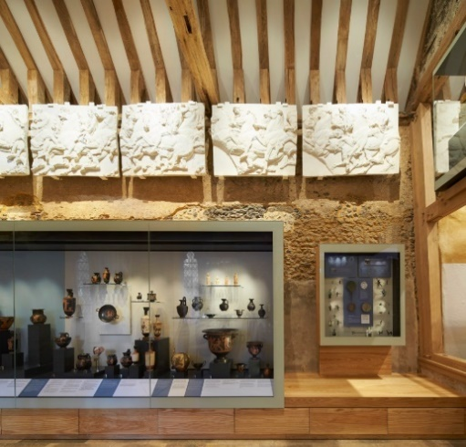Teaching takes place in a classroom at Winchester College, meaning we will be in easy reach of the school’s excellent collections of Greek vases, casts, coins and texts. The format of the OCR GCSE in Classical Greek is similar to that of the Eduqas Latin GCSE course followed in most Winchester schools. Those who have studied Latin will find much that is familiar in the study of ancient Greek, and are likely to make rapid progress in the language. Some pupils are put off by the Greek alphabet, but typically they conquer this within a couple of weeks (and have a lot of fun doing so!).

Greek vases and casts on display in the Winchester College Treasury (the school's museum)

Participation in the club is free of charge. Participants will be lent copies of the textbook, John Taylor’s *Greek to GCSE* Parts 1 and 2 (though they are welcome to buy their own), and will be supplied with all course materials.

If your child is interested in taking part, please could you fill in this parental consent form, as soon as possible and no later than Thursday 5th September 2024?

One of the vases in the Winchester College Treasury (open to the public free of charge every day from 2-4pm)

<https://forms.office.com/e/dKiNE9k31D>

If you have any questions, please do email me at [easl@wincoll.ac.uk](mailto:easl@wincoll.ac.uk).

Yours sincerely,

*Edmund Lewis*

Head of Classics

Winchester College

Participants of the Winchester Greek Club visiting Oxford in June 2023